Student Data Management

Functions of Program:

1. Enter details of student.
2. Print List Of All Student.
3. Search Student( By Roll number).
4. Update Student Information( By Unique Registration Number).
5. Delete Student Information( By Roll number).

Concept used in Program:

1. Abstract Class and Method.
2. Single level Inheritance.
3. Unique Random number Generator.
4. Switch case.
5. Assertion.
6. Exception Handling.

PROGRAM(Code)

import java.util.Scanner;

import java.util.*;

import java.security.SecureRandom;

//CONCEPT OF ABSTRACT CLASS USED

abstract class Student

{

int i,j,count;

Scanner sc=new Scanner(System.in);

String[] Name=new String[20];

int Age[]=new int[20];

int Roll_no[]=new int[20];

int[] Reg_no=new int[20];

String[] Course=new String[20];

int[] Year=new int[20];

//METHOD FOR SEARCH STUDENT INFORMATION

abstract void search();

//METHOD FOR UPDATE STUDENT INFORMATION

abstract void update();

//METHOD FOR DELETE STUDENT INFORMATION

abstract void delete();

}

//USING SINGLE LEVEL INHERITANCE

class MyClass extends Student

{

//METHOD FOR ENTERING STUDENT INFORMATION

void Student_info()

{

System.out.println("Enter Details of student");

int [] result=createUniqueRandomNumbers(10000000,20000000);

//int n=sc.nextInt();

for (i=count;i<20;i++)

{

System.out.println("Enter name : ");

Name [i]=sc.next();

System.out.println("Registration number IS : "+result[i]);

Reg_no[i]=result[i];

System.out.println("Enter age : ");

Age [i]=sc.nextInt();

System.out.println("Enter roll number : ");

Roll_no [i]=sc.nextInt();

System.out.println("Enter Course : ");

Course [i]=sc.next();

System.out.println("Enter Year : ");

Year [i]=sc.nextInt();

count++;

break;

}

}

//METHOD FOR DISPLAY LIST OF ALL STUDENT

void disp()

{

System.out.println("NAME: AGE: ROLL NUMBER: REG NUMBER COURSE YEAR ");

for (i=0;i<count;i++)

{

System.out.println(Name[i]+" " +Age[i]+" "+Roll_no[i]+" "+Reg_no[i]+" "+Course[i]+" "+Year[i]);

}

}

//DEFINING SEARCH METHOD

void search()

{

System.out.println("Enter roll number to search: ");

int key=sc.nextInt();

System.out.println("NAME: AGE: ROLL NUMBER: REG NUMBER COURSE YEAR ");

for(j=0;j<count;j++)

{

if(Roll_no[j]==key)

{

System.out.println(Name[j]+" " +Age[j]+" "+Roll_no[j]+" "+Reg_no[j]+" "+Course[j]+" "+Year[j]);

}

}

}

//DEFINING UPDATE

void update()

{

System.out.print("Enter registration number of Student:");

Scanner sc=new Scanner(System.in);

int key=sc.nextInt();

for(j=0;j<count;j++)

{

if(Reg_no[j]==key)

{

System.out.println("Enter name : ");

Name [j]=sc.next();

System.out.println("Enter age : ");

Age [j]=sc.nextInt();

System.out.println("Enter roll : ");

Roll_no [j]=sc.nextInt();

System.out.println("Enter Course : ");

Course [j]=sc.next();

System.out.println("Enter Year : ");

Year [j]=sc.nextInt();

}

}

}

//DEFINING DELETE METHOD

void delete()

{

int x;

Scanner sc=new Scanner(System.in);

System.out.println("Enter roll number of student want to deletes : ");

int target=sc.nextInt();

for (x=0;x<20;x++)

{

if(target==Roll_no[x])

{

Name[x]=Name[x+1];

Age[x]=Age[x+1];

Roll_no[x]=Roll_no[x+1];

Reg_no[x]=Reg_no[x+1];

Course[x]=Course[x+1];

Year[x]=Year[x+1];

count--;

}

}

}

//GENERATING UNIQUE REGISTRATION NUMBER

static int [] createUniqueRandomNumbers(int from,int to)

{

int n=to-from+1;

int a[]=new int[n];

for(int i=0;i<n;i++){

a[i]=i;

}

int[] result=new int[n];

int x=n;

SecureRandom rd=new SecureRandom();

for(int i=0;i<n;i++){

int k=rd.nextInt(x);

result[i]=a[k];

a[k] = a[x-1];

x--;

}

return result;

}

public static void main(String[] args)

{

Scanner sc=new Scanner(System.in);

int select_key;

System.out.println("********************************************Student Data Management System*************************************************");

MyClass M=new MyClass();

//Exception HANDLING CONCEPT

try

{

start:

do{

System.out.println("select 1:Enter Student Detail\t\tselect 2:Show Student List\t\tselect 3:Search Student\nselect 4:Update Record\t\t\tselect 5:Delete Record\t\t\tselect 6:Exit Program");

select_key=sc.nextInt();

switch(select_key)

{

case 1:

{

M.Student_info();

continue start;

}

case 2:

{

M.disp();

continue start;

}

case 3:

{

M.search();

continue start;

}

case 4:

{

M.update();

continue start;

}

case 5:

{

M.delete();

continue start;

}

case 6:

{

break;

}

}

}while(select_key<6);

}

catch(Exception e)

{

System.out.print(e);

System.out.println(" : Please Entet Valid Input");

}

}

}

ScreenShots of outputs

Entering details of three student(User can insert more than three student information)

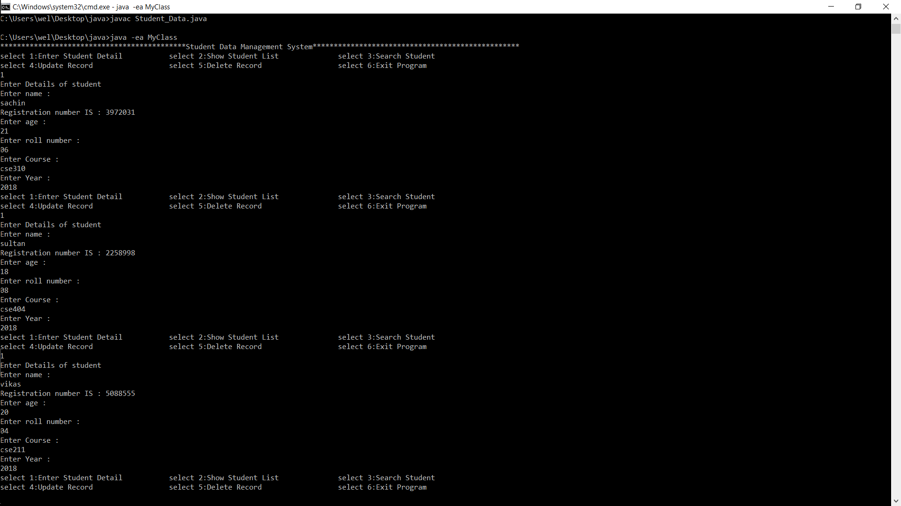

Print list Of All Students:

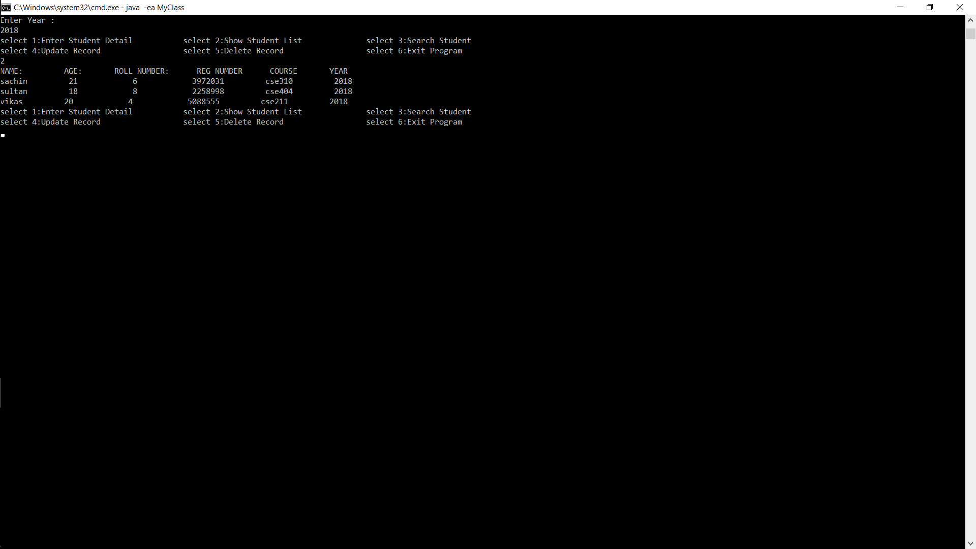

Search Student by its Roll number:

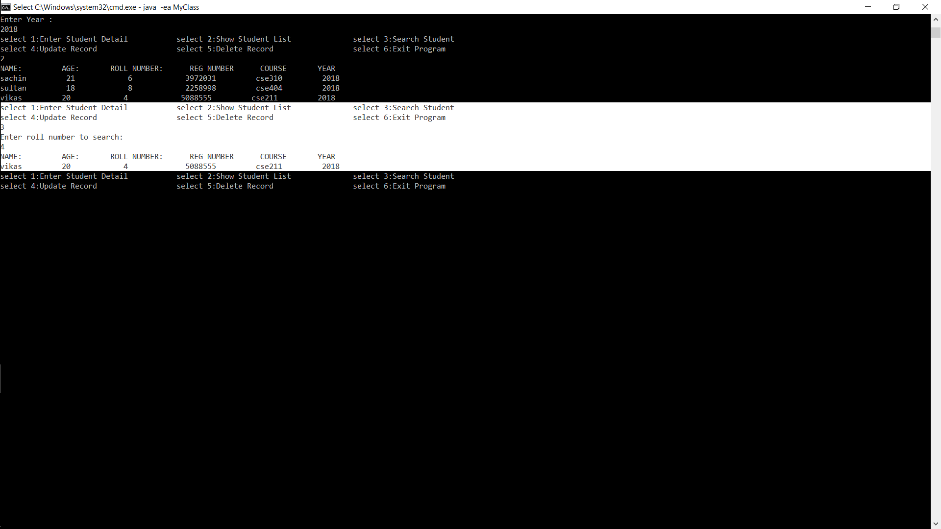

Update information of student by its Registration number:

List before Update:

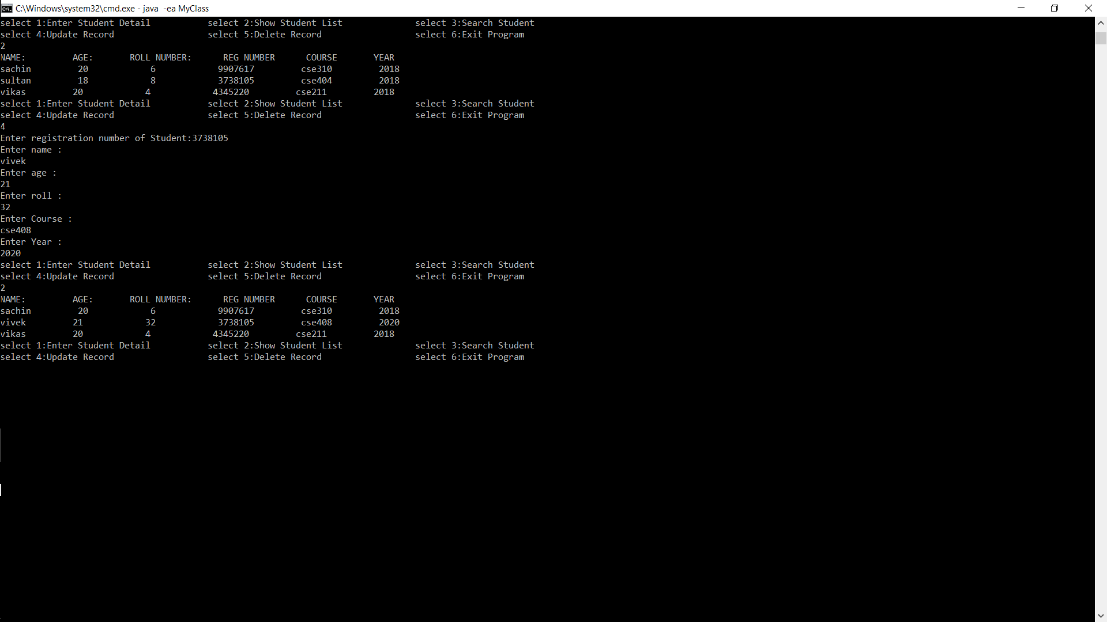

List After Update:



Delete Student Details:

List before Deleting:

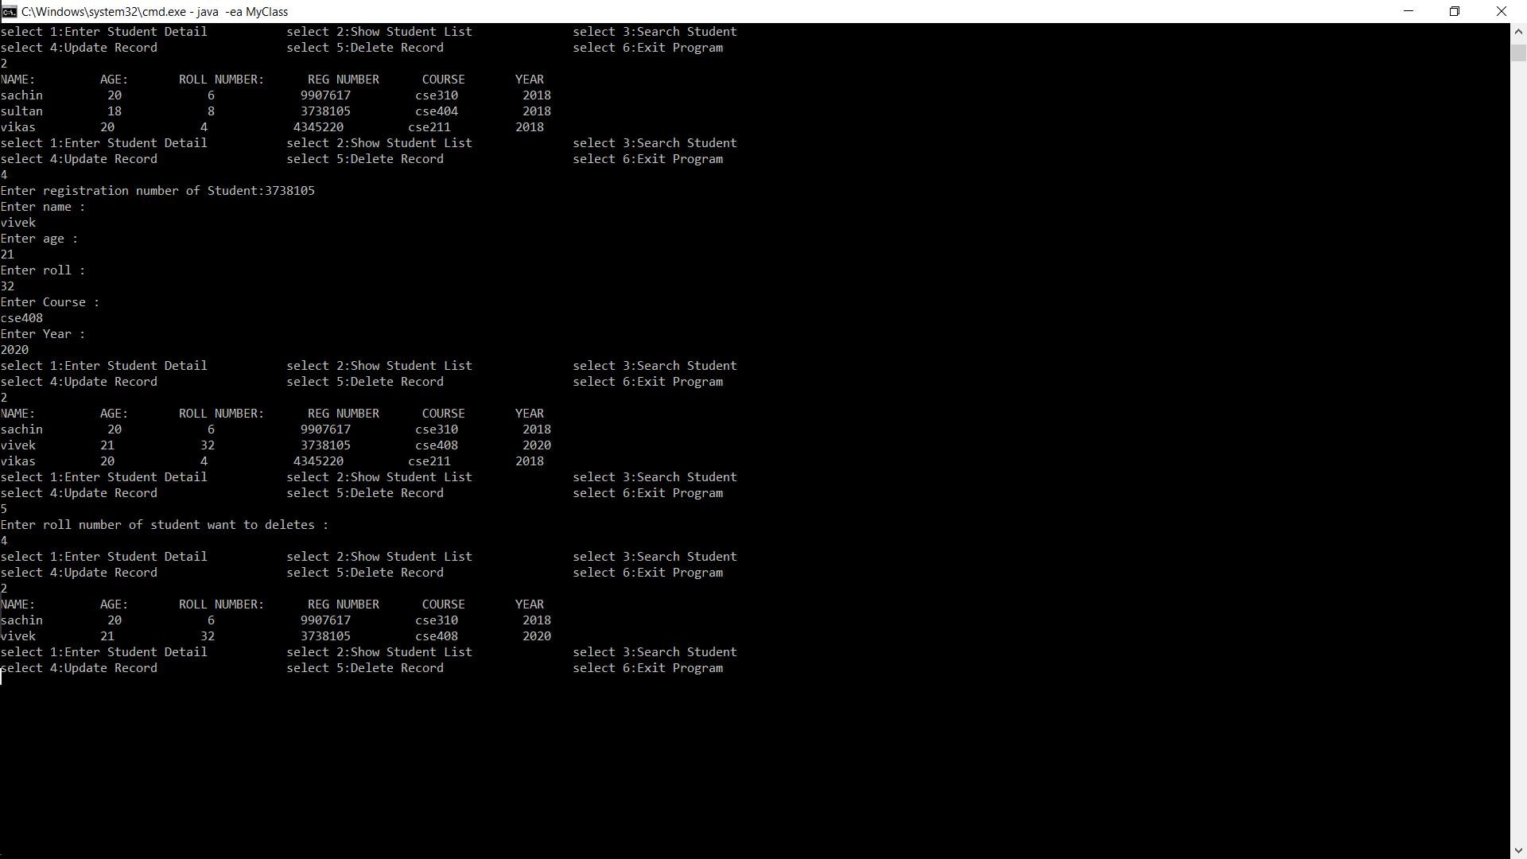

List after deleting:



Assertion comes into picture When we exceed input Limit:

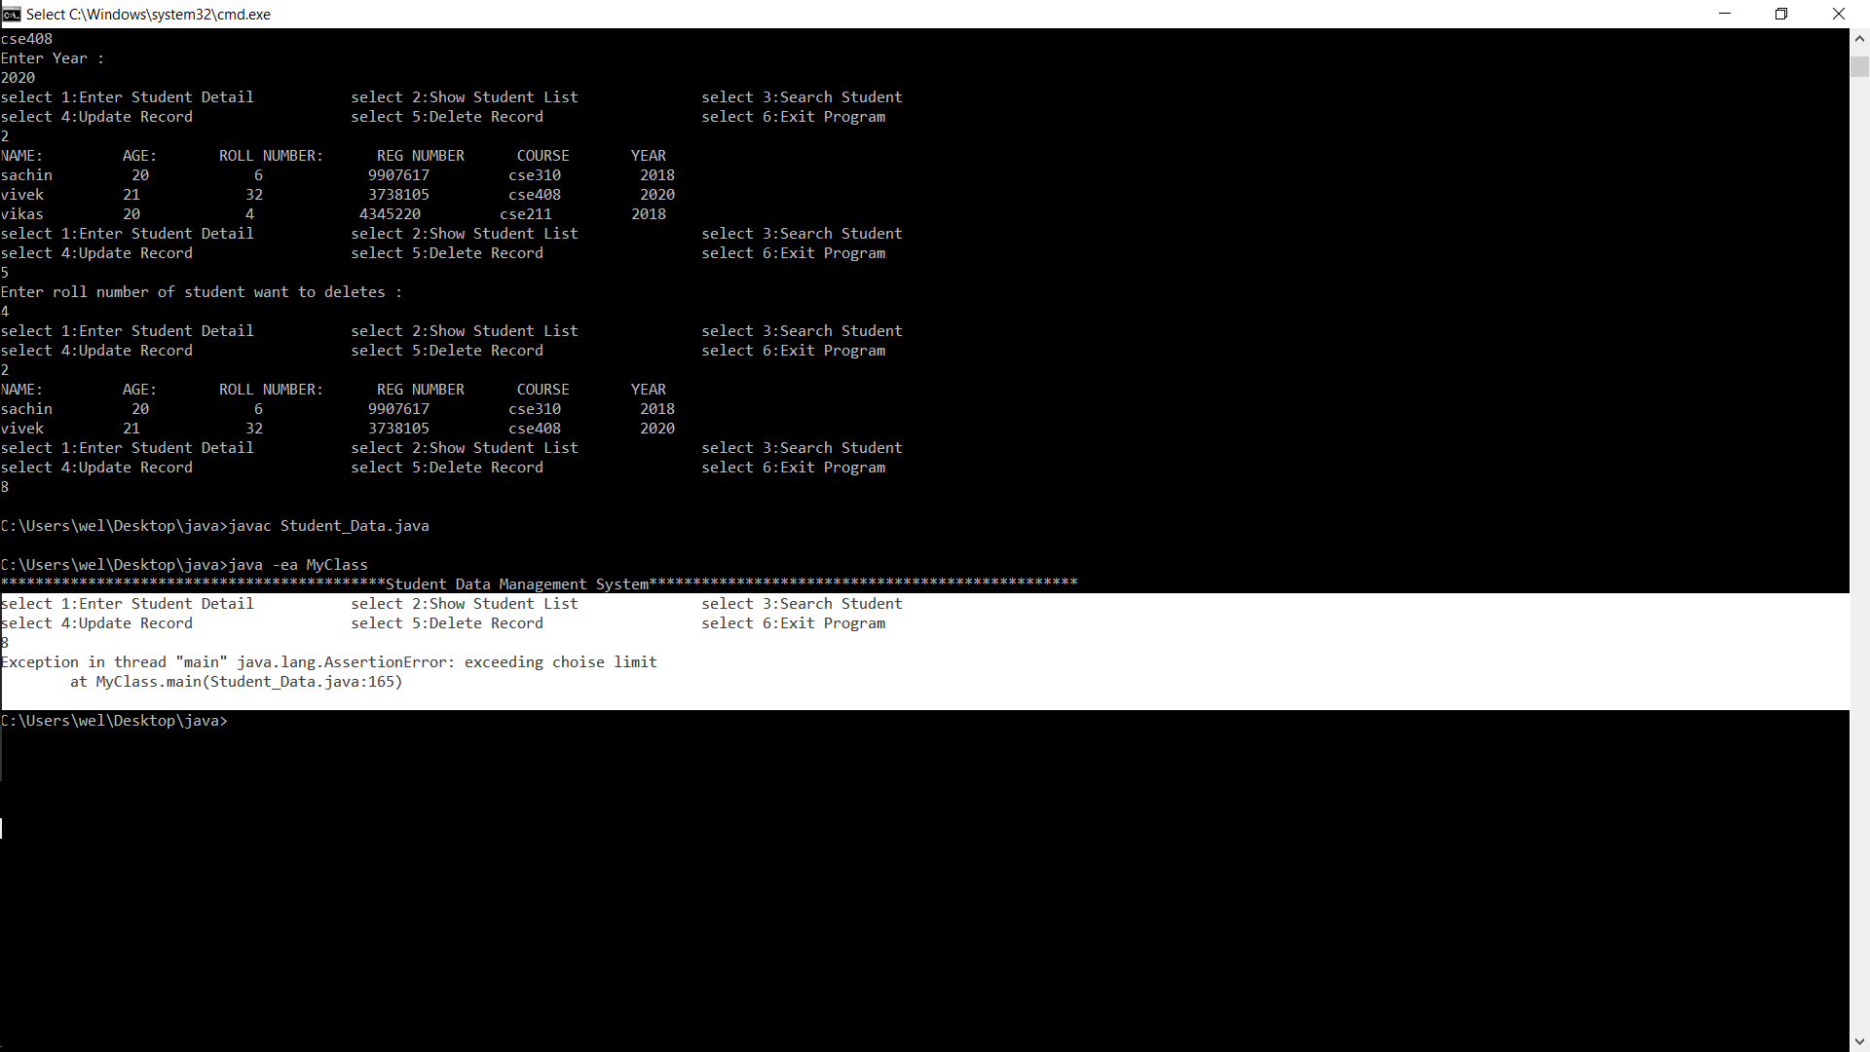

Handling with Exceptions: in place of integer give String as Input in place of Age

